Date: July 15, 2022

From: Yuhang Zhai

To: Kelly Ellis

Re: Turnitin explanation of citations

This memo will record my Turnitin check. The following paragraphs are explanations specific repetitive sentences.

The overall structure of the report is basically fixed. The words in the similar catalogue lead to similarity. At the same time, similar "development of solar energy and wind energy" or other professional terms and their references will lead to similarity. But my current report is similar to my previous draft, which cannot be included.

A Recommendation Report By

Yuhang Zhai

2022SU-15531-ENGI2304

For the

Kelly Ellis

Contents

List of Tables and Figures 4

Abstract 4

Introduction 4

Purpose 4

Background 4

Scope 5

Criteria 1. Efficiency 5

Explanation 5

Data 5

Interpretation 5

Criteria 2. Cost 6

Explanation 6

Data 6

Interpretation 6

Conclusion 7

Summary 7

Conclusions 7

Recommendation 7

Contact 7

References 7

# List of Tables and Figures

Table. 1 The data is from sources [1] 2

Figure.1 The data is from the sources [2][3] 3

Abstract

# This report compares wind energy and solar energy through discussion. At present, energy shortages and environmental problems are becoming more and more serious. I first introduced the social background and utilization principle of these two kinds of energy, and then compared their utilization efficiency and cost respectively. Finally, I summarize the data and come to the conclusion that solar energy is more advantageous than wind energy.

Introduction

Purpose

The purpose of this report is to compare wind energy and solar energy, and determine which energy is more suitable for the development needs of human society in the future.

Background

With increasing energy demand in the world and strengthening environmental protection, the spread and use of clean energy are inevitable. The precise definition of clean energy should be to clean, efficiently and systematically apply energy technology. Clean energy emphasizes clean energy as well as stress. Clean energy cleanliness means that it conforms to some emission standards. Traditionally, clean energy refers to environmentally friendly energy, i.e., environmental protection, decrease in emissions and decrease in pollution. It is green energy that does not drain pollutants and can be used directly for production and life.

Solar energy clean energy is a new energy that converts solar energy into other forms of thermal energy, electrical energy and chemical energy, and does not generate other harmful gases or solid waste in the energy conversion process. Environmentally friendly, safe and polluted. As a result of life cycle analysis (LCA) for the broad use of solar energy, the solar photovoltaic panels were based on solar panels, and solar panels were high pollution and energy consumption materials in the production process, and cost and environmental cost were high. Thermoelectric research is directed toward the heat utilization of solar heat.

Wind energy is mainly used in wind and wind power generation, and wind power generation is the main form. The use of wind energy refers to direct driving of various mechanical equipment using wind power. The advantages of wind turbines are less investment, more efficient, economical and durable. Wind energy sources are seriously affected by the terrain, and most of the world's wind energy sources are concentrated in the coastal and wide continental contractions. In nature, the wind is a renewable and no polluting energy reserve. With global warming and energy crisis, all countries are scrambling to develop and use wind energy to reduce greenhouse gas emissions as much as possible.

Scope

For the purpose of making a recommendation, the report will compare solar energy and wind energy based on only two Criteria: efficiency and cost. The research results may be applicable to most areas limited by fossil fuels. People may consider these factors when talking about clean energy.

Discussion

Criteria 1. Efficiency

Explanation

The most common use of wind and solar energy is to generate electricity. Due to the poor efficiency caused by discharge and charging, the actual efficiency will be reduced when the power generation efficiency at some time of the day is less than the required power at the beginning of the day. In order to quantify and compare this efficiency, I chose a specific case for comparison:

(1) No energy storage related technology

(2) The energy generated is just enough for all buildings to consume.

(3) The manual efficiency of the charging station is 100%. Although solar / wind power stations all need labor, labor does not affect efficiency.

Data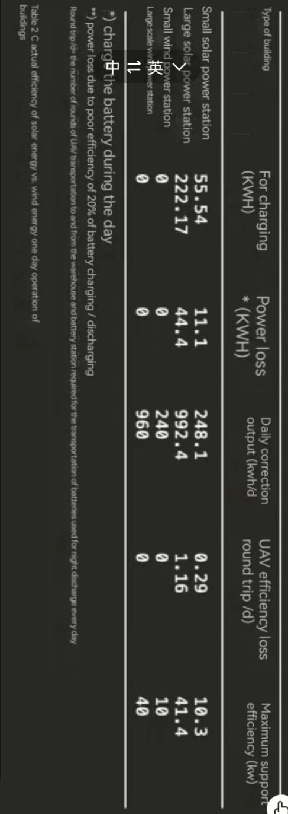

Table.1 Actual efficiency of solar energy vs. wind energy one day operation of buildings.[1]

Interpretation

From the table we can see that the efficiency of solar power stations with the same scale is very close to that of wind power stations on the whole. The efficiency of solar power stations is slightly higher than that of wind power stations. In this way, solar power stations have advantages. If there is enough sunshine, the efficiency of solar power plants will be higher. However, the wind power station has obvious changes in the size of the air flow, and the efficiency is not stable enough.

Criteria 2. Cost

Explanation

Wind energy and solar energy can cause such a storm in today's capital markets because the cost for markets is beginning to become competitive. In addition, the speed and the range of the cost reduction are not limited to other power generation methods.Wind energy is the alternative energy alternative to oil, coal and natural gas, except for the few developed countries that use solar energy widely. But this situation will change.

Data

The latest manufacturing data show that in some markets, the average price of solar power per watt has been lower than that of wind power per watt. For example, Vestas' report shows that the average price of wind power in the first quarter of this year was $1.34 per watt, while the price of solar power last year was $0.7 to $0.8 per watt.

Figure.1 Photovoltaic power generation costs vs.offshore and onshore wind power costs.[2][3]

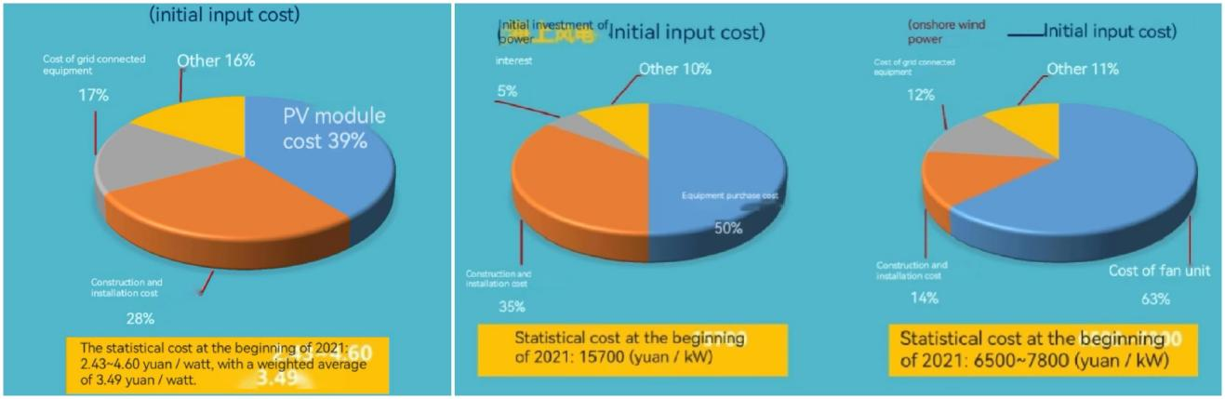

Interpretation

We can see from the chart that the proportion of infrastructure investment in wind power generation is very high, whether it is offshore or onshore. In contrast, the economic benefits of photovoltaic power generation are higher. The final data also shows that the cost of photovoltaic power generation is lower than that of wind power generation, in the case of unified units.

Considering the expected decline in the wind energy market, the amount of solar power generation in the world this year is expected to exceed wind energy. The price drop of solar power plants rapidly reduced the difference between them.

Conclusion

Summary

With the strengthening of environmental protection and the increase of world energy demand, the promotion and use of clean energy has become an inevitable trend. Based on the two standards of efficiency and cost, this report compares solar energy and wind energy to determine which energy has more advantages in social development. In terms of efficiency, there is little difference between solar power plants of the same scale and wind power plants. Solar power stations are slightly better. In terms of cost, the gap between the two is obvious. As the unit ratio of solar energy is relatively low, with the increase of scale, the advantages of solar energy are gradually highlighted.

Conclusions

In summary, solar power has an advantage over wind in clean energy if viewed in terms of efficiency and cost. Because in both respects, solar energy is superior to style. Although there is little difference in efficiency, wind power has a disadvantage over solar power in cost. Considering the reality, large clean power plants are flooded with equipment like windmills or solar panels. The initial cost will be an astronomical number. This is particularly evident in large-scale energy use. So we choose solar energy.

Recommendation

I suggest using solar energy instead of wind energy for clean energy in the future. The benefits and conditions of using solar energy are very suitable for the sustainable development of world energy. Of course, with the development of science and technology and the change of energy structure, the impact of other kinds of factors is unknown. So far, I think solar energy can replace wind energy.

Contact

If you have any questions about this report, I'm happy to answer them for you. My email is [2220202533zyh@dlmu.edu.cn](mailto:2220202533zyh@dlmu.edu.cn).

References

[1] Shuang Tan. December 11, 2020. Available at: <https://www.sohu.com/na/437590356_120930212>

[2] Shuang Tan. February 21, 2022. Available at: <1.00 JIV:/ https://v.douyin.com/26u8P4t/>

[3] Shuang Tan. February 21, 2022. Available at: <7.12 cAt:/ https://v.douyin.com/26H1do9/>